A low-cost real-time human activity recognition system based on supervised learning algorithms

Nhung Tran Thi Hong^{1,} Nguyen Quang Huy², Van Thanh Pham³, Duc-Nghia Tran³, Duc-Tan Tran^{4, *}
¹ Faculty of Electrical and Electronic Engineering, Phenikaa University, Hanoi 12116, Vietnam
² Institute of Information Technology, Vietnamese Academy of Science and Technology, Hanoi, Vietnam
³ The University of Fire Fighting and Prevention, Hanoi, Vietnam
*Corresponding:
Email: tan.tranduc@phenikaa-uni.edu.vn (D.-T.T.)
Tel.: +84-9-0418-2389 (D.-T.T.)

Abstract— Human activity recognition systems support the assessment of the health condition by providing the subject’s activity information. Machine learning algorithms offer high-performance monitoring of acceleration data. Accelerometers are simple to install, and their price is low. Thus, a human activity recognition system based on accelerometers is one of the leading solutions for monitoring health conditions. The major challenges in real-world context applications are the performance, the price, and the real-time requirement. An optimal time frame, a feature set, and a lightweight machine learning model are proposed in this paper to build a low-cost and responsive recognition system that works in real-time. A high recognition rate of 99.2% was achieved on a recorded dataset for four daily activities (Standing, Sitting, Running, and Walking) with a simple features set. The results were verified on both public data and our experiment data.
Keywords—recognition activity, classification, accelerometer, feature extraction

- INTRODUCTION
In the past several decades, the research on human activity recognition has expanded thanks to its applications in several fields. Activity recognition offers solutions for an increasing number of practical problems, such as healthcare [1], [2], fall detection for the elderly [3], [4], industry [5], and security [6]. Activity recognition technology collects user behaviour information, provides various ways to interact, and allows the system to actively support users in their work [7].
With the development of technology, more advanced sensors improve the recognition rate and adapt to different situations. In the process of human activity recognition, there are three common approaches: the computer vision-based approach, the environment interactive sensor-based approach, and the wearable sensor-based approach [8]. A camera or video is employed for a vision-based approach to observe user behaviour and the surrounding environment changes [9]–[13]. However, limitations of surveillance cameras include poor performance in low-light conditions, the high cost, and potential privacy concerns. With an environment interactive sensor-based approach, the sensor is embedded in an object in the surrounding environment to monitor user activity [14], [15], [16], [17]. Like the computer vision-based approach, this system needs to be deployed and pre-installed.
In contrast to the above approaches, the wearable sensor-based approach using on-body sensors has opened up many potential applications in human activity recognition [18], [19], [20], [21]. They are suitable for any environment without set-up, whether indoor or outdoor. In this approach, the sensor can be worn in many different positions on the human body, such as arm, wrist [22], thigh [23], front pocket [24], or ankle [25]. This study focuses on performing human state recognition using sensors carried on the body.
Several studies stood out when using multi-sensors to recognize human behaviour. Bao et al. [23] collected data from five biaxial accelerometers and placed them on various locations such as hips, wrist, arms, ankles, and thighs on the research group. Accuracy from the Decision Tree classifier for the results was 84% with 20 activities classified. However, the drawbacks were the increased number of sensors, high speed, and the need to set the accelerometer to a specific orientation. Aiguo et al. [8] also compared the individual use of accelerometer and gyroscope sensors with the simultaneous use of both based on KNN and Naïve Bayes classifiers for recognition. Experimental results showed that accelerometers provided more discriminatory information than gyroscopes and that the simultaneous use of both sensor types gave better classification performance. Naïve Bayes gave an overall accuracy of 90.1%, which is higher than KNN's 87.8%. Multiple sensors could provide high accuracy, but wearing the sensors interfered with human movement, and they were impractical to wear for long periods. In addition, the cost of the system increased with the number of sensors.
Recently, many researchers have looked for activity recognition methods that use only one accelerometer to collect the signal [26]. For example, Gupta et al. [27] explored the benefits of a belt-worn, 3-axis accelerometer to collect data to build an activity recognition and feature selection system. They used two classifiers, Naïve Bayes and KNN, and found that using feature selection with a wrapper-based approach gave better results than filter-based. The classification results showed > 95% accuracy for all six activities. But the limitation was that the data collection only included seven subjects. They were all young people, aged only 22-28 years old. Like Gupta, Khan et al. [28] used a single 3-axis accelerometer mounted on the chest in a specific direction to distinguish different activities in daily life. The overall accuracy result was up to 97.9% with a classification of 15 behaviours. However, when testing was carried out at five different locations, the system accuracy decreased by only 47%.
To overcome these limitations, this study focuses on using a single 3-axis accelerometer integrated into the low-cost system to reduce the ability to impede human movement. It will analyse data from many objects to determine whether data was distributed in clusters corresponding to different activities. Our work offers several contributions. The first major contribution proposed in this field is using and demonstrating a simple feature set that gives good classification performance. The second one is to provide a low-cost recognition system and real-time response.
The content of this paper is summarized as follows. Section 2 describes the classification model, details data processing, analyses our proposed feature set, and determines performance measurements. Section 3 describes classification results, discusses our proposed method, and compares it to some other methods. The last section summarizes our results and proposes future research.

- METHODOLOGY
  - Activities Recognition Model
Some of the machine learning models classified by learning style are supervised learning, unsupervised learning, semi-supervised learning, and reinforcement learning. A supervised learning algorithm predicts the outcome or label of a new input from the mapping function that generates the known (input, outcome) pair. Conversely, unsupervised learning has only input data without an outcome or label to predict. Semi-supervised learning is a technique with a large amount of data, but only a portion is labelled. And a reinforcement learning model allows the system to decide the best subsequent behaviour based on the current state to maximize performance. In this study, the supervised learning approach was used to gain higher accuracy. The overall approach included three phases of human activity recognition: data acquisition, features analysis, and activities recognition, as shown in Figure 1.
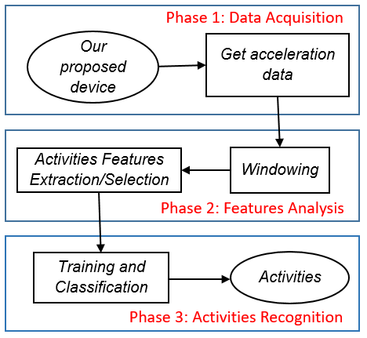
Figure 1. Block diagram of classification state process
In Phase 1, from our proposed device for classifying activities, we gathered acceleration data in three axes Ax, Ay, and Az. In Phase 2, we divided the data stream into small segments. Here, a sliding window was deployed to shift along the stream to capture all information about activities. Then, each vector generated from the above segments would contain features extracted from the data. The next step was to conduct feature selection to use as the input of the classifier. And in the last phase, the features selected from the previous step were used to build classification models. Based on the model learned, the classifiers were obtained to identify activities. Details of each task will be presented in the respective following sections.

  - Data Acquisition
To support classification, the proposed system integrated a sensor, a low-cost inertial measurement unit (IMU), and a wireless data transmitter/receiver into the wearing device. This device will transfer data to a smartphone running the Android operating system. This system significantly decreases user inconvenience while recording data. Figure 2 illustrates our proposed system structure.

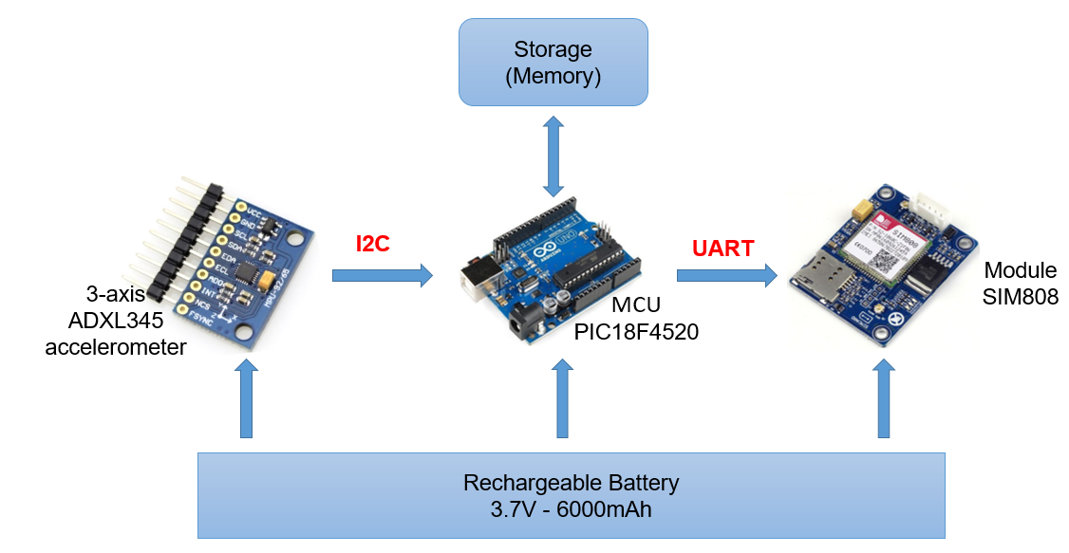 | 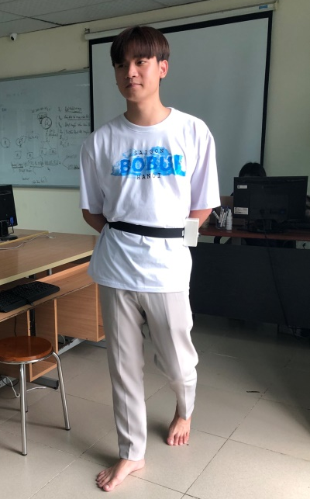
(a) | (b)
Figure 2. Block diagram of our proposed system (a) and the photo of a volunteer wearing the device (b).
The accelerometer ADXL345 (3-DOF accelerometer) was connected to the MCU (PIC18F4520) by an I2C (inter-integrated circuit) interface to acquire data along three axes, Ax, Ay, and Az. In addition, Module SIM808 communicated with the MCU via UART (Universal Asynchronous Receiver/Transmitter) communication. In this design, the device was powered by a rechargeable battery of 3.7V and 6000 mAh.
We deployed our experiment with a Dell E6540 laptop with a 2.7 GHz processor and 8 GB RAM. We conducted empirical data recording with a group of 14 students (seven males and seven females); ages: 18-22, height: 1.56-1.8 m, and weight: 43-62 kg, who were selected from The University of Fire Fighting and Prevention (UFFP) and two older adults aged between 65 and 72, height: 1.4 m and 1.46 m, weight: 38 kg and 42 kg to obtain daily activities data. Our proposed device was attached to the waist of the students and had a sampling frequency of 50 Hz. It recorded four states: Standing for 43 minutes, Sitting for 32 minutes, Running for 10 minutes, and Walking for 22 minutes. Additionally, to test the algorithm's accuracy, we also used a public dataset [24]. This dataset was also collected from daily activities with an accelerometer and the participation of thirty-six people. Table 1 below shows detailed descriptions and some illustrations of activities.

Table 1. Description human activities
Activity | Description
Standing | Standing with subtle movements
Sitting | Sitting on a chair
Jogging | Jogging
Walking | Normal walking, stairs up and stairs down
After building the model as shown in Figure 1 and designing the system with hardware devices as shown in Figure 2, we applied the algorithm to this device. The microcontroller was the Central Processing Unit of the embedded device. Therefore, when performing real-time identification, there were memory requirements and algorithmic complexity. Consequently, the Decision Tree algorithm was suitable for deploying human activity recognition on wearable devices in real-time. The decision tree was based on the data after training to give the feature thresholds to form a binary decision tree. Thus, we programmed the wearable device to recognize the real-time activity. Figure 3 below illustrates the proposed algorithm flowchart.
To establish the connections between the sensor, the MCU, and the SIM Module, we performed the following steps: First, we declared the ADXL variable from the ADXL345 library to set up the threshold values of activity or inactivity, set up the tap detection on the axes, and set the interrupt for step Set up. In the Loop step, we decided which activity was based on the Decision Tree algorithm. Every six seconds, the device calculated, analysed, and returned the measured activity results to ensure real-time response and minimal complexity.

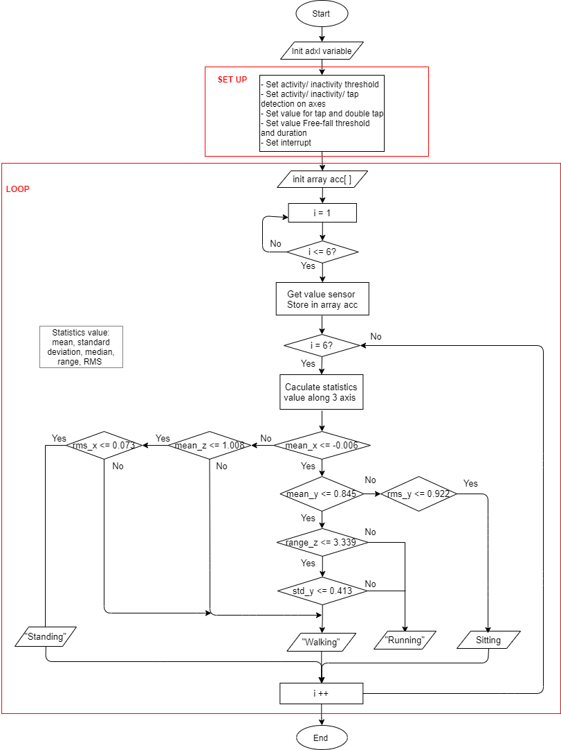
Figure 3. The flowchart for our device
  - Features Analysis
- Windowing
The acceleration data collected from the sensor was used to analyse the features of the activities. First, we divided the data stream into small segments that can potentially contain action information. The subjects performed activities smoothly, and activities that occurred in succession affected each other. Also, determining the exact boundary of an activity was quite difficult, so segmentation of the data was essential.
There were many methods for segmentation, such as segmentation using a sliding window, energy-based segmentation, rest-position segmentation, the use of one sensor modality to segment data of a sensor of another modality, and external context sources [29]. In this paper, the sliding window approach was chosen to segment data because of its simple implementation and lack of pre-processing suitable for real-time application [30]. This approach was proven effective for recognizing periodic (e.g., walking, running) and static (e.g., standing, sitting) activities. In this technique, the sensor signals are partitioned into fixed-size time windows. These can be of two types: non-overlapping (time windows do not intersect) and overlapping windows (adjacent time windows intersect).
The selection of the window size significantly affects the recognition performance of the system. Consequently, it was necessary to experiment with different window sizes to choose the optimal value. J.R. Kwapisz [24] segmented the data into a 10s window size without overlapping and demonstrated that the 20s window size gave less promising results. To select the best size, we conducted experiments with many different sizes (1s – 22s) with overlapping intervals [0%, 95%] and found good results for a window with a fixed length of 10s with 50% overlapping. If the chosen window length is too short, the window will not provide enough information to describe activities. Conversely, if the window size is too large, it could accommodate the information of various types of activity in a single time window. By choosing this length of the window, the effective measurements contained the entire process of all behaviour to ensure the integrity of each activity.
First, we conducted the public data analysis. The number of activity observations using a 10s window size appears in Table 2. The extracted dataset contains a total of 10482 observations with 50% overlapping.

Table 2. Composition of activity observations public data
Behaviour pattern | Number of observations
Standing | 445
Sitting | 548
Jogging | 3258
Walking | 6231
Total | 10482
- Proposed Feature Extraction
To get high classification efficiency, the selection of features that inform the activities is extremely important. In this section, feature selection was performed before feature extraction. For feature selection, we analysed partial data of each activity. Part of the data (the 200 first samples) obtained from the sensor in the X-axis is represented in Figure 5 to determine the sensor value ranges and characteristics corresponding to each activity.
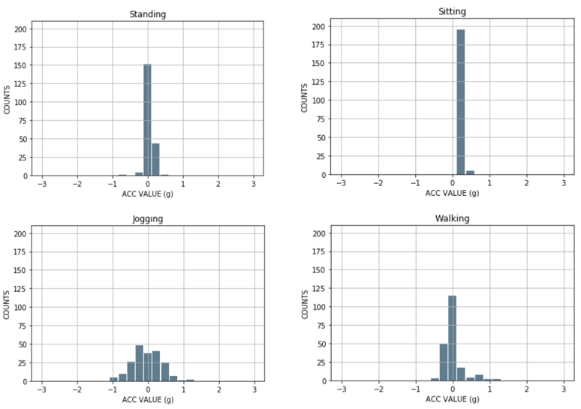
Figure 4. Histogram of a partial representation of data in X-axis
Figure 5 shows that the static states (Standing, Sitting) had values within a specific small range. For example, Standing had about 150 values concentrated at a_{x} ≈ 0g; Sitting had nearly 200 values along the X-axis centred at (0.12g, 0.36g). Therefore, we could easily use two features, mean and median, to measure the concentration of data to distinguish static states from dynamic states and separate static states from each other.
In addition, dynamic states, such as Jogging and Walking, had a wider range of values than static states. According to Figure 5, the X-axis sensor value of Jogging had a variation range (-1.08g, 1.32g), Walking ranged (-0.6g, 1.32g), while the range of Sitting was (0.12g, 0.6g). Consequently, the range was selected to determine the difference between these states' highest and lowest values.
Also, from Figure 5, between the dynamic states, Walking data had the largest value density at x = (0.12g, 0.12g) and was sparse on both sides. Meanwhile, Jogging had more even density of values than Walking. Therefore, standard deviation (SD) was a feature to determine the data spread of this activity when compared to the mean to measure the difference from another state.
As shown in Figure 5, Standing and Walking had more a_{x} ≈ 0g values than Sitting and Jogging, so it was possible to choose root mean square (RMS) to characterize these activities.
The five statistical features we analysed above included mean, standard deviation (SD), median, range, and RMS. Acceleration data calculated according to these statistical features of the activities in X, Y, and Z dimensions appear in Table 3-5.
Table 3. Acceleration data in X dimension (g)
 | Standing | Sitting | Jogging | Walking
Mean | -0.07 | 0.19 | 0.00 | 0.12
SD | 0.30 | 0.45 | 0.92 | 0.57
Median | -0.11 | 0.16 | 0.00 | 0.07
Range | 2.46 | 2.32 | 4.03 | 4.03
RMS | 0.31 | 0.49 | 0.92 | 0.58

Table 4. Acceleration data in Y dimension (g)
 | Standing | Sitting | Jogging | Walking
Mean | 0.93 | 0.22 | 0.58 | 0.88
SD | 0.11 | 0.32 | 0.94 | 0.50
Median | 0.97 | 0.26 | 0.49 | 0.89
Range | 2.05 | 2.83 | 4.04 | 4.04
RMS | 0.94 | 0.39 | 1.10 | 1.01

Table 5. Acceleration data in Z dimension (g)
 | Standing | Sitting | Jogging | Walking
Mean | 0.07 | 0.68 | -0.01 | 0.01
SD | 0.14 | 0.39 | 0.60 | 0.40
Median | 0.08 | 0.84 | -0.02 | -0.02
Range | 1.16 | 2.53 | 4.01 | 3.97
RMS | 0.15 | 0.79 | 0.60 | 0.40
In Table 3, mean distinguished Standing (-0.07) from Sitting (0.19) in static states according to X-axis. In Table 4, SD could characterize Jog (0.92) from Standing (0.11). The median feature distinguished Standing (-0.11) from other activities (> -0.05) or Sitting (0.84) with the others (< 0.1) (according to Table 5). The range of acceleration distinguished Standing (1.16) and Jogging (4.01) (according to Table 5). In Table 3, RMS helped distinguish Jogging (0.92) from Walking (0.58) or Standing (0.15) with the others (> 0.3) (according to Table 5).
The formulas of the five features (mean, standard deviation, median, range, and RMS) in Table 6 below were calculated on the X-axis, and the formulas on the Y-axis and Z-axis were similar.
Table 6. Definition of features: consider a signal X
 | where:  $X_{j}$ is the j^{th} record;  N is the total of data samples (a window size);  $x_{i}$ is the i^{th} sample of the record $X_{j}$;  $µ(X_{j})$ is mean of $X_{j}$;  $σ(X_{j})$ is the standard deviation of $X_{j}$;  min is the minimum value of $X_{j}$;  max is the maximum value of $X_{j}$;  ${RMS}_{X_{j}}$ is the root mean square of $X_{j}$.
  Features | Formula
  Mean | $µ(X_{j})=\frac{1}{N}$ $\sum_{i=1}^{N}{x_{i}}$
  Standard  deviation | $σ(X_{j})$ = $\sqrt{\frac{1}{N} \sum_{i=1}^{k}{{{(x}_{i}-µ)}^{2}} }$
  Median | $median(X_{j})=\frac{x_{\left(\#\frac{N}{2}\right)}+ x_{\left(\#\frac{N}{2}+1\right)}}{2}$, $X_{j}$ was sorted
  Range | range($X_{j}$) = [$\min_{i=1}^{N}\{x_{i}\}$, $\max_{i=1}^{N}\{x_{i}\}$]
  RMS (root  mean square) | ${RMS}_{X_{j}}$ = $\sqrt{\frac{1}{N} \sum_{i=1}^{N}{{x_{i}}^{2}} }$
After deciding to use the above five features, we divided the data set into two parts: a training set and a test set of 60% and 40%, respectively. We then use the proposed features to explore the training dataset to build the model. To have a clearer view of the training dataset contribution, we used an algorithm to reduce the number of data dimensions for simpler observation. Compared to Principal Components Analysis (PCA), a dimensional reduction algorithm with only linear data, t-Distributed Stochastic Neighbour Embedding (t-SNE) helps visualize nonlinear data by mapping multidimensional data to two or more dimensions consistent with human observation. This paper used the t-SNE tool to map each point in 3-dimensional space (x,y,z) into 2-dimensional space.
Without using the features, it was easy to see confusion between most activities (Figure 6-a). But in Figure 6-b, when experimenting with all five statistical features mentioned above, the boundary between the activities became clearer. Using all the features always yielded better classification results than just using the individual features. We could see Standing (orange area) and Sitting (blue area) were easily classified. Jogging (pink area) and Walking (green area) were well classified, however, there was some overlapping.
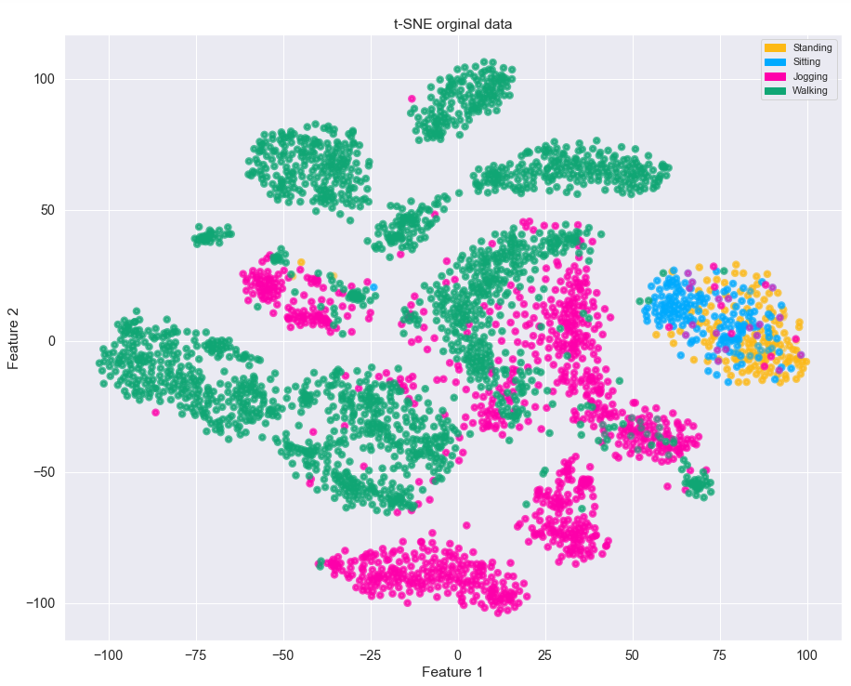  (a) | 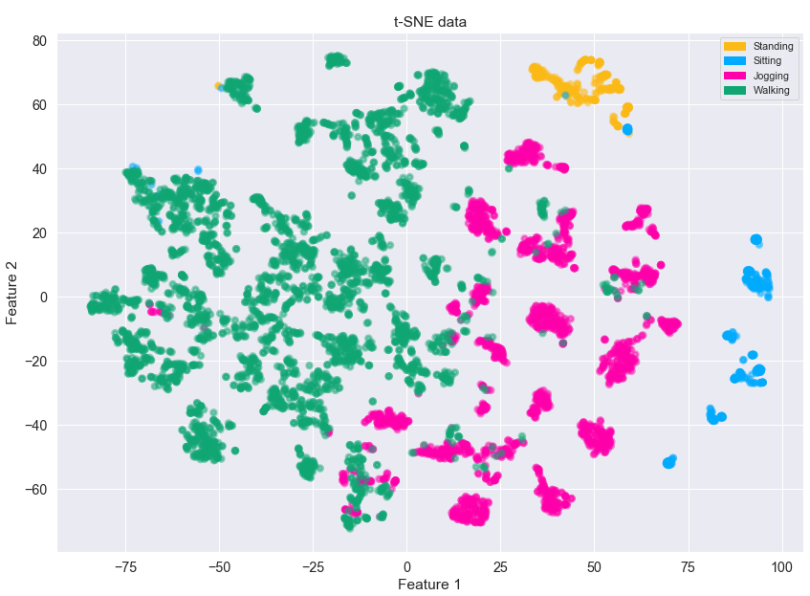  (b)
Figure 5. Representation of public data in 2D space (a) without features (b) with features
Similar to public data, we also applied the above five features to our recorded data. Below is the number of activity observations using 10s window size (Table 7) and a representation of the training data using the t-SNE algorithm. The extracted dataset contains a total of 1283 observations with 50% overlapping.
Table 7. Composition of activity observations our recorded data
Behaviour pattern | Number of observations
Standing | 517
Sitting | 383
Running | 118
Walking | 265
Total | 1283

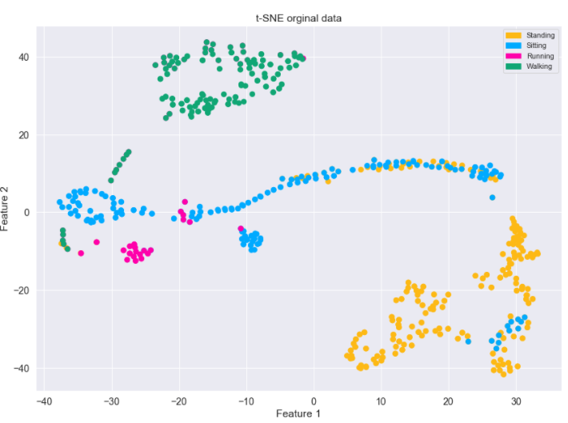  (a) | 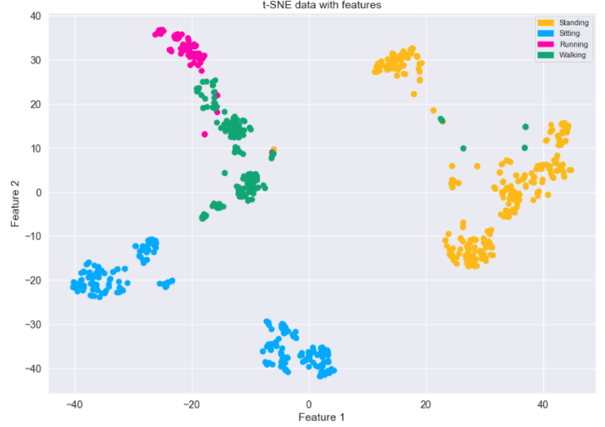 (b)
Figure 6. Representation of our proposed data in 2D space
- without features (b) with features
In Figure 7-a, Walking data (green area) and Running data (pink area) were classified quite well. But there was still considerable confusion between Standing (orange area) and Sitting (blue area). After using five features, the overlap between Standing and Sitting was gone, and the boundary between them was separated (Figure 7-b). However, there was a very small overlap between Running and Walking.
  - Activities Recognition
The classifier is the key to identify activities. Besides the high accuracy and short training time, classifiers often must meet real-time requirements. The feature set extracted in Section Features Analysis would be input to the training and classification process. Classification methods were widely used in machine learning. Data analysis methods such as Gradient Boosted Decision Tree, Support Vector Machine, Random Forest, and k-Nearest Neighbour through the available library Sklearn were used to evaluate the performance of the classification model.
  - Estimation method
The performance of a classification model is often evaluated against a test dataset. There are different ways to measure this performance, but the most widely used is the confusion matrix. The confusion matrix contains the actual output and the predicted output to estimate the classification performance. Accordingly, a few common measurements are deployed to improve recognition, such as overall accuracy, sensitivity, PPV, and NPV. The formulas for these measurements are shown below:
$$Accuracy= \frac{TP+TN}{TP + FP+FN+TN}$$ | (1)
$$Sensitivity= \frac{TP}{TP+ FN}$$ | (2)
$$PPV=\frac{TP}{TP+FP}$$ | (3)
NPV = $\frac{TN}{TN + FN}$ | (4)
Where:
True Positive (TP) is an outcome when an activity happens, and the model predicts it happened.
False Positive (FP) is an outcome when an activity does not happen, but the device predicts it happened.
False Negative (FN) is an outcome when an activity happens, but the device predicts a different activity to happen.
True Negative (TN) is an outcome when an activity does not happen, and the device also predicts that it does not happen.
The above datasets show a significant difference in size between data classes (Walking data was relatively large compared to Standing - Table 2), Two metrics, micro-average, and macro-average, would be appropriate for the evaluation classification of the dataset.
Micro-average is defined according to the following formula with TP_{c}, FP_{c}, FN_{c}, TN_{c} being TP, FP, FN, and TN of class C, respectively:
micro-average accuracy = $\frac{\sum_{c=1}^{C}{{(TP}_{c}+ {TN}_{c})}}{\sum_{c=1}^{C}{{(TP}_{c}+{FP}_{c}+{FN}_{c}+{TN}_{c})}}$ | (5)
micro-average sensitivity = $\frac{\sum_{c=1}^{C}{{TP}_{c}}}{\sum_{c=1}^{C}{{(TP}_{c}+{FN}_{c})}}$ | (6)
micro-average PPV = $\frac{\sum_{c=1}^{C}{{TP}_{c}}}{\sum_{c=1}^{C}{{(TP}_{c}+{FP}_{c})}}$ | (7)
micro-average NPV = $\frac{\sum_{c=1}^{C}{{TN}_{c}}}{\sum_{c=1}^{C}{{(TN}_{c}+{FN}_{c})}}$ | (8)
Macro-average is the average of the values of the classes:
macro-average accuracy = $\frac{1}{C}\sum_{c=1}^{C}{\frac{{TP}_{c}+ {TN}_{c}}{{TP}_{c}+{FP}_{c}+{FN}_{c}+{TN}_{c}}}$ | (9)
macro-average sensitivity =$\frac{1}{C}\sum_{c=1}^{C}{\frac{{TP}_{c}}{{TP}_{C}+{FN}_{c}}}$ | (10)
macro-average PPV = $\frac{1}{C}\sum_{c=1}^{C}{\frac{{TP}_{c}}{{TP}_{C}+{FP}_{c}}}$ | (11)
macro-average NPV = $\frac{1}{C}\sum_{c=1}^{C}{\frac{{TN}_{c}}{{TN}_{c}+{FN}_{c}}}$ | (12)

- RESULTS AND DISCUSSION
  - Experimental Results
We could easily compare the performance of each classifier, such as Gradient Boosted Decision Tree, Support Vector Machine, Random Forest, and k-Nearest Neighbour (KNN), based on their overall accuracy (Figure 7) and sensitivity (Figure 8) on the public dataset with different window sizes (5s, 8s, 10s, 12s, 15s). The Random Forest classifier gave the best classification performance on both measurements: 95.3% accuracy and 94% sensitivity both 10s window size.
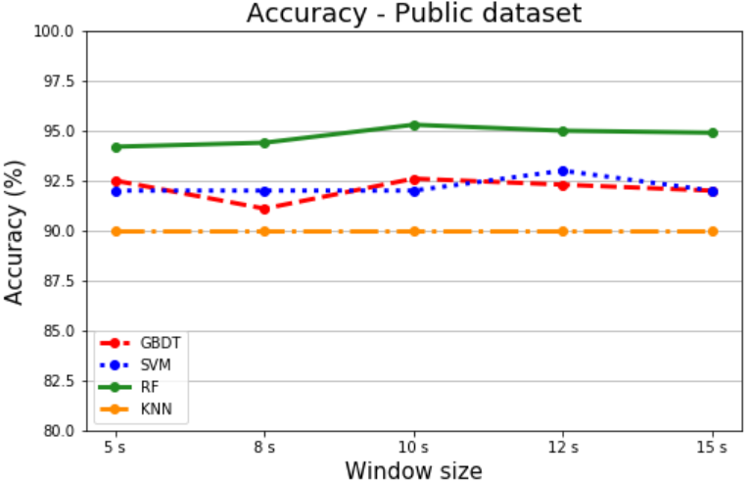  Figure 7. Accuracy of public dataset | 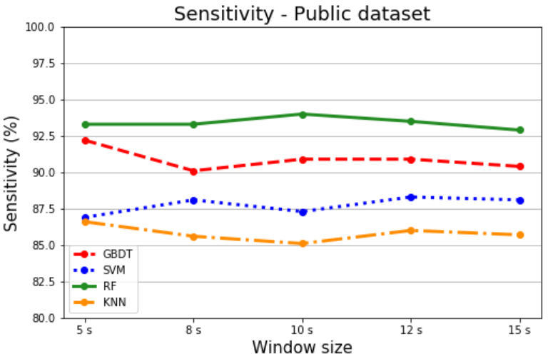  Figure 8. Sensitivity of public dataset
Like the public dataset, Figure 9 and Figure 10 represent the accuracy and sensitivity of our recorded dataset, respectively, with different window sizes and different classifiers. On both measurements, the KNN classifier had the highest accuracy (100%), and the Random Forest (99.8%) classifier had the highest sensitivity, both with 8s window size.
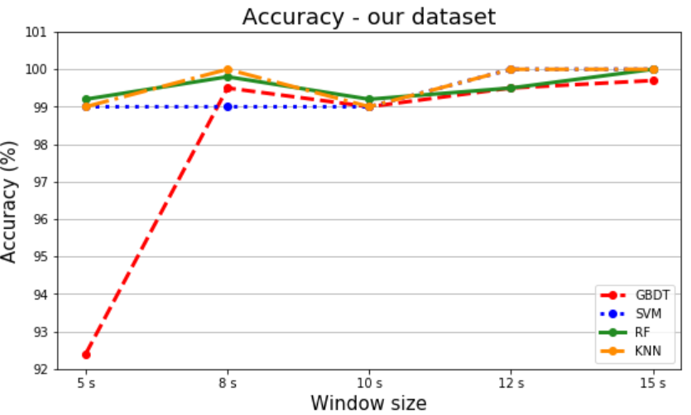  Figure 9. Accuracy of our dataset | 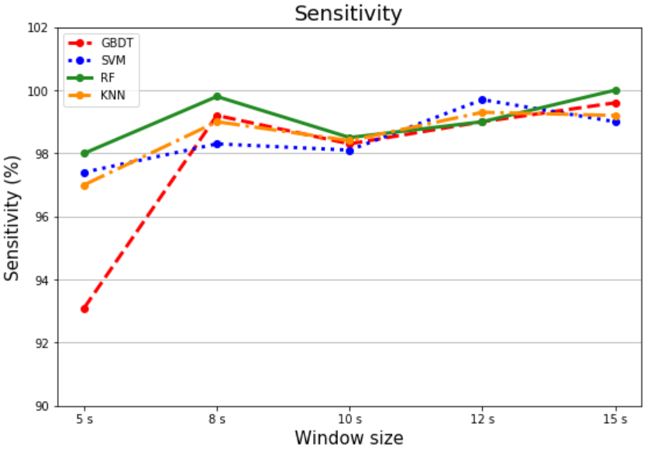  Figure 10. Sensitivity of our dataset
The detailed results for using the Random Forest classifier were represented by the confusion matrix of public data (Table 8) and our recorded data (Table 9). From Table 8, most of the test samples of behaviours are relatively well-differentiated (166/177 Standing test samples, 208/218 Sitting test samples, 1137/1302 Jogging test samples, 2481/2491 Walking test samples). But it also shows that 173 samples are misclassified between Jogging and Walking. Between Standing and Sitting, only 12 samples were misclassified.
Table 8. Confusion matrix of public data
Observed  behaviour | Predicted behaviour |  |  |  | Total
Observed  behaviour | Standing | Sitting | Jogging | Walking | Total
Standing | 166 | 9 | 0 | 2 | 177
Sitting | 3 | 208 | 0 | 7 | 218
Jogging | 0 | 0 | 1137 | 165 | 1302
Walking | 0 | 2 | 8 | 2481 | 2491
Total | 169 | 219 | 1145 | 2655 | 4188
Table 9. Confusion matrix of our data
Observed  behaviour | Predicted behaviour |  |  |  | Total
Observed  behaviour | Standing | Sitting | Jogging | Walking | Total
Standing | 206 | 0 | 0 | 0 | 206
Sitting | 0 | 151 | 1 | 0 | 152
Running | 0 | 0 | 44 | 2 | 46
Walking | 0 | 0 | 1 | 104 | 105
Total | 206 | 151 | 46 | 106 | 509
As with the public dataset, in Table 9, most test samples of activities were very well-differentiated (206/206 Standing test samples, 151/152 Sitting test samples, 44/46 Running test samples, and 104/105 Walking test samples). Only three test samples were misclassified between Running and Walking.
Performance indicators classify all activities (Section 2.5 - accuracy (1), sensitivity (2), PPV (3), and NPV (4)) represented in Table 10 and Table 11 on the public dataset and our dataset.
Table 10. Performance of model using indicators on the public dataset
Behaviour  pattern | Algorithm performance indicators
Behaviour  pattern | Accuracy | Sensitivity | PPV | NPV
Standing | 99.7% | 93.8% | 98.2% | 99.7%
Sitting | 99.5% | 95.4% | 95% | 99.7%
Jogging | 95.9% | 87.3% | 99.3% | 94.6%
Walking | 95.6% | 99.6% | 93.4% | 99.3%

Table 11. Performance of model using indicators on our recorded dataset
Behaviour  pattern | Algorithm performance indicators
Behaviour  pattern | Accuracy | Sensitivity | PPV | NPV
Standing | 100% | 100% | 100% | 100%
Sitting | 99.8% | 99.3% | 100% | 99.7%
Jogging | 99.2% | 95.7% | 95.6% | 99.6%
Walking | 99.4% | 99% | 98.1% | 99.8%
The Random Forest classifier gave a relatively high classification result. The accuracy and NPV of all activities were excellent (> 95% on the public dataset and > 99% on our dataset). Sensitivity and PPV had good values (> 93%) for all classes except Jogging (87.3%) on public dataset and > 95% on our data. In particular, Standing had an absolute indicator value, which was completely classified compared to the rest of the activities.
The overall performance of the dataset using two metrics (micro-average and macro-average – Section 2.5) were shown in Table 12 with the best performing classifier Random Forest. The results were relatively high with the micro-average estimation method (>95% on the public dataset and > 99% on our dataset). As for macro-average evaluation, based on the independent calculation of each class and averaging, we got slightly lower results: > 94% on the public dataset and > 98% on our dataset).
Table 12. The measurements to evaluate the performance of the RF classification model
Evaluation method | Micro-average |  | Macro-average
Evaluation method | Public dataset | Our recorded dataset | Public dataset | Our recorded dataset
Accuracy | 97.7% | 99.6% | 97.7% | 99.6%
Sensitivity | 95.3% | 99.2% | 94% | 98.5%
PPV | 95.3% | 99.2% | 96.5% | 98.4%
NPV | 98.4% | 99.7% | 98.3% | 99.8%

  - Discussion
Today’s health care needs are increasingly focused, especially for patients and the elderly. Advanced activity recognition applications are integrated to support human activities. Feature selection plays an essential role in the recognition process. Many studies choose several features to improve the rate of activity identification, such as 43 features [24], [31], [32] or 64 features [33]. The present study only uses a simple and effective set of five statistical features and the best sliding window size for a relatively high recognition efficiency of 95.3% (public dataset) and 99.2% (our recorded dataset). Moreover, in our study, the classification process is made by the microcontroller in real time. Figure 11 shows the received data at the terminal (i.e., the smartphone) where the raw acceleration and the classification results are displayed.
There is a difference in the results of the overall accuracy with the public and our recorded datasets (99.2% versus 95.3%). The more significant number of participants in the public dataset (36 participants compared to 16 volunteers in our recorded data) resulted in more diversity in the sample data than the data we collected.
With the same WISDM public dataset, the accuracy in [33] was higher with two classifiers (Ibk - 99.79% and J48 - 98.63%). However, Vavoulas et al. used up to 64 features to achieve such accuracy, while our algorithm used fewer features (15 features) and achieved an accuracy of 95.3% with Random Forest.
Catal et al. [31] applied the voting algorithm by combining J48, Logistic Regression, and Muli-Layer Perceptron; the result was 91.6%. Although they classified more activities (six) than our study, they also tested a more complex algorithm when combining many different classification algorithms. Moreover, they used 43 features and did not mention a low-cost design as we did.
Our algorithm could be applied to patients or the elderly, but it could not generalize to the group of people doing hazardous tasks such as firefighters, because the activities of these subjects often took place with higher intensity in complex conditions such as large fires or dense smoke. Besides, an apparent limitation of the device was the need to fix the position of the sensor on the waist.
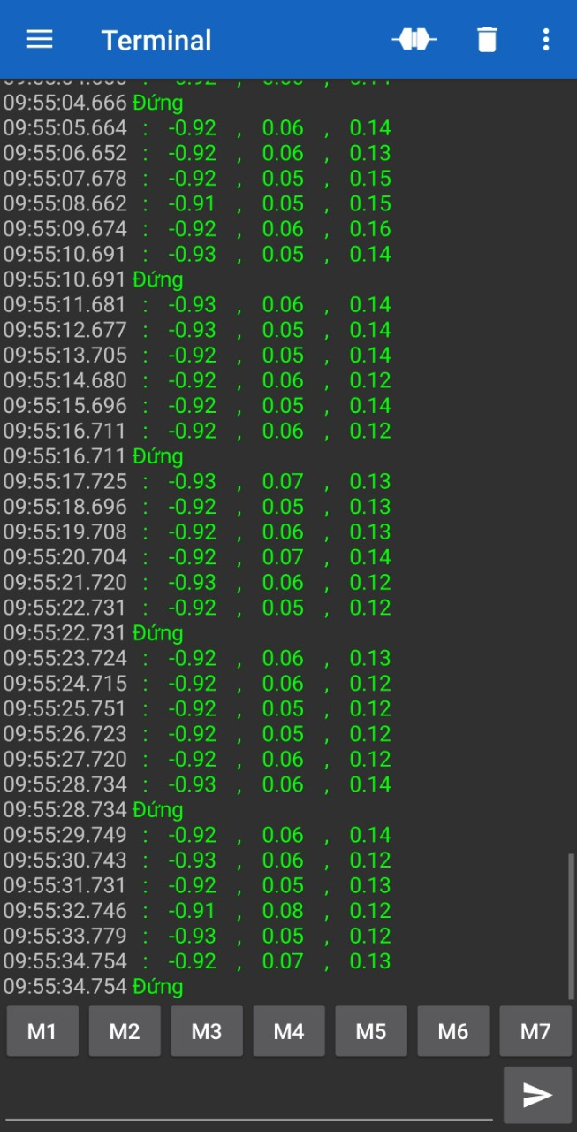 | 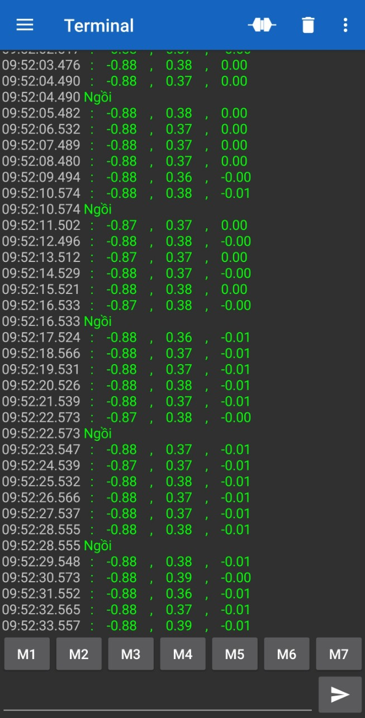 | 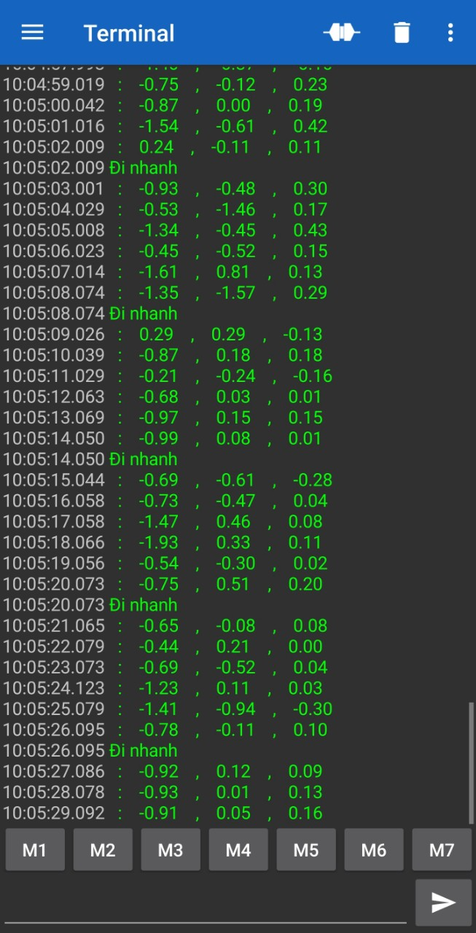 | 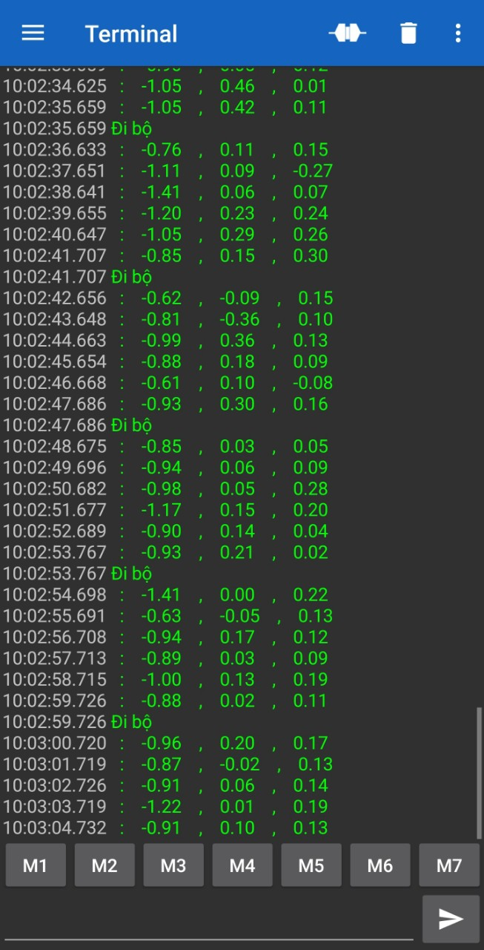
Standing | Sitting | Jogging | Walking
Figure 11. Real-time classification at the microcontroller
- CONCLUSION
This study builds a recognition system with low cost, short computation time, and real-time response. The results of this study confirm that a simple set of five features can classify everyday behaviours well, even though different individuals perform these behaviours. When combined with a 10s window size and classifier, the test results show that the Random Forest classifier helps the algorithm achieve higher overall accuracy than Gradient Boosted Tree, SVM, and KNN. For future research, we will further develop and confirm these initial findings by experiments on more complex activities to check the accuracy of the proposed model. Furthermore, in addition to the statistical features in the time domain, we can extend the extraction to other features such as features in the frequency domain or combining information in both time and frequency domains in the feature extraction process. Also, experiments can use machine learning models such as the deep learning method to find the most optimal solution suitable for the classification problem. Furthermore, we tend to develop systems that automatically classify more complex behaviours to support and care for patients or the elderly more effectively in specific circumstances.

REFERENCES
[1] S. Chernbumroong, S. Cang, A. Atkins, and H. Yu, "Elderly activities recognition and classification for applications in assisted living," Expert Systems with Applications, vol. 40, no. 5, pp. 1662–1674, 2013.
[2] K. K. B. Peetoom, M. A. S. Lexis, M. Joore, C. D. Dirksen, and L. P. De Witte, "Literature review on monitoring technologies and their outcomes in independently living elderly people," Disability and Rehabilitation: Assistive Technology, vol. 10, no. 4, pp. 271–294, 2015.
[3] P. Pierleoni, A. Belli, L. Palma, M. Pellegrini, L. Pernini, and S. Valenti, "A High Reliability Wearable Device for Elderly Fall Detection," IEEE Sensors Journal, vol. 15, no. 8, pp. 4544–4553, 2015.
[4] S. E.-R. Pham Van Thanh, Duc-Tan Tran, Dinh-Chinh Nguyen, Nguyen Duc Anh, Dang Nhu Dinh and K. Sandrasegaran, "Development of a Real-Time, Simple and High-Accuracy Fall Detection System for Elderly Using 3-DOF Accelerometers," Arabian Journal for Science and Engineering, pp. 3–4, 2018.
[5] T. Stiefmeier, D. Roggen, G. Ogris, and P. Lukowicz, “Batra97.Pdf,” pp. 42–50, 2008.
[6] A. Jain and V. Kanhangad, "Exploring orientation and accelerometer sensor data for personal authentication in smartphones using touchscreen gestures," Pattern Recognition Letters, vol. 68, pp. 351–360, 2015.
[7] N. N. Diep, C. Pham, and T. M. Phuong, "A classifier based approach to real-time fall detection using low-cost wearable sensors," 2013 International Conference on Soft Computing and Pattern Recognition, SoCPaR 2013, pp. 105–110, 2013.
[8] A. Wang, G. Chen, J. Yang, S. Zhao, and C. Y. Chang, "A Comparative Study on Human Activity Recognition Using Inertial Sensors in a Smartphone," IEEE Sensors Journal, vol. 16, no. 11, pp. 4566–4578, 2016.
[9] C. W. Lin and Z. H. Ling, "Automatic fall incident detection in compressed video for intelligent homecare," Proceedings - International Conference on Computer Communications and Networks, ICCCN, pp. 1172–1177, 2007.
[10] F. Marquis-Faulkes, S. J. McKenna, A. F. Newell, and P. Gregor, "Gathering the requirements for a fall monitor using drama and video with older people," Technology and Disability, vol. 17, no. 4, pp. 227–236, 2005.
[11] W. Y. Shieh and J. C. Huang, "Speedup the multi-camera video-surveillance system for elder falling detection," Proceedings - 2009 International Conference on Embedded Software and Systems, ICESS 2009, pp. 350–355, 2009.
[12] L. Hazelhoff, J. Han, and P. H. N. De With, "Video-Based Fall Detection in the Home Using," pp. 298–309, 2008.
[13] S. Torres, "Aging in Place: Fall Detection and Localization in a Distributed Smart Camera Network," Critical Gerontology Comes of Age: Advances in Research and Theory for a New Century, pp. 151–163, 2018.
[14] M. Sundholm, J. Cheng, B. Zhou, A. Sethi, and P. Lukowicz, "Smart-mat: Recognizing and counting gym exercises with low-cost resistive pressure sensing matrix," UbiComp 2014 - Proceedings of the 2014 ACM International Joint Conference on Pervasive and Ubiquitous Computing, pp. 373–382, 2014.
[15] T. Rahman et al., "DoppleSleep: A contactless unobtrusive sleep sensing system using short-range doppler radar," UbiComp 2015 - Proceedings of the 2015 ACM International Joint Conference on Pervasive and Ubiquitous Computing, pp. 39–50, 2015.
[16] S. Jamil, A. Basalamah, A. Lbath, and M. Youssef, "Hybrid participatory sensing for analyzing group dynamics in the largest annual religious gathering," UbiComp 2015 - Proceedings of the 2015 ACM International Joint Conference on Pervasive and Ubiquitous Computing, pp. 547–558, 2015.
[17] P. Hevesi, S. Wille, G. Pirkl, N. Wehn, and P. Lukowicz, "Monitoring household activities and user location with a cheap, unobtrusive thermal sensor array," UbiComp 2014 - Proceedings of the 2014 ACM International Joint Conference on Pervasive and Ubiquitous Computing, pp. 141–145, 2014.
[18] C. Zhu and W. Sheng, "Wearable sensor-based hand gesture and daily activity recognition for robot-assisted living," IEEE Transactions on Systems, Man, and Cybernetics Part A: Systems and Humans, vol. 41, no. 3, pp. 569–573, 2011.
[19] M. H. Lee, J. Kim, K. Kim, I. Lee, S. H. Jee, and S. K. Yoo, "Physical activity recognition using a single tri-axis accelerometer," Proceedings of the world congress on engineering and …, vol. I, pp. 20–23, 2009.
[20] S. W. Lee and K. Mase, "Activity and location recognition using wearable sensors," IEEE Pervasive Computing, vol. 1, no. 3, pp. 24–32, 2002.
[21] J. Pärkkä, M. Ermes, P. Korpipää, J. Mäntyjärvi, J. Peltola, and I. Korhonen, "Activity classification using realistic data from wearable sensors," IEEE Transactions on Information Technology in Biomedicine, vol. 10, no. 1, pp. 119–128, 2006.
[22] Nishkam Ravi and Nikhil Dandekar and Preetham Mysore and Michael L. Littman, "Activity recognition from accelerometer data," Lecture Notes in Networks and Systems, vol. 43, pp. 317–329, 2019.
[23] L. Bao and S. S. Intille, "Activity Recognition from User-Annotated Acceleration Data BT - UbiComp 2002: Ubiquitous Computing," UbiComp 2002: Ubiquitous Computing, vol. 3001, no. Chapter 1, pp. 1–17, 2004.
[24] J. R. Kwapisz, G. M. Weiss, and S. A. Moore, "Activity recognition using cell phone accelerometers," ACM SIGKDD Explorations Newsletter, vol. 12, no. 2, pp. 74–82, 2011.
[25] B. H. Dobkin, X. Xu, M. Batalin, S. Thomas, and W. Kaiser, "Reliability and validity of bilateral ankle accelerometer algorithms for activity recognition and walking speed after stroke," Stroke, vol. 42, no. 8, pp. 2246–2250, 2011.
[26] W. Xiao and Y. Lu, "Daily Human Physical Activity Recognition Based on Kernel Discriminant Analysis and Extreme Learning Machine," Mathematical Problems in Engineering, vol. 2015. 2015.
[27] P. Gupta and T. Dallas, "Feature selection and activity recognition system using a single triaxial accelerometer," IEEE Transactions on Biomedical Engineering, vol. 61, no. 6, pp. 1780–1786, 2014.
[28] A. M. Khan, Y. K. Lee, S. Y. Lee, and T. S. Kim, "A triaxial accelerometer-based physical-activity recognition via augmented-signal features and a hierarchical recognizer," IEEE Transactions on Information Technology in Biomedicine, vol. 14, no. 5, pp. 1166–1172, 2010.
[29] A. Bulling, U. Blanke, and B. Schiele, "A tutorial on human activity recognition using body-worn inertial sensors," ACM Computing Surveys, vol. 46, no. 3, pp. 1–33, 2014.
[30] O. Banos, J. M. Galvez, M. Damas, H. Pomares, and I. Rojas, "Window size impact in human activity recognition," Sensors (Switzerland), vol. 14, no. 4, pp. 6474–6499, 2014.
[31] C. Catal, S. Tufekci, E. Pirmit, and G. Kocabag, "On the use of ensemble of classifiers for accelerometer-based activity recognition," Applied Soft Computing Journal, vol. 37, pp. 1018–1022, 2015.
[32] Y. Min, Y. Yin, and K. Khin, "Comparing the Performance of Machine Learning Algorithms for Human Activities Recognition using WISDM Dataset," International Journal of Computer, vol. 4523, pp. 61–72, 2020.
[33] G. Vavoulas, C. Chatzaki, T. Malliotakis, M. Pediaditis, and M. Tsiknakis, "The MobiAct dataset: Recognition of activities of daily living using smartphones," ICT4AWE 2016 - 2nd International Conference on Information and Communication Technologies for Ageing Well and e-Health, Proceedings, no. Ict4awe, pp. 143–151, 2016.

Microcontroller unit
Sklearn is the most popular and powerful machine learning library. It is written in Python and provides many tools for processing supervised and unsupervised learning problems.

